SSE2 Project Report
BoCoLa


Course: | SSE2 Spring 2010
Teacher: | Bent Brunn Kristensen
Faculty: | Faculty of Engineering at SDU
Due date: | Spring 2010

Group 1

Martin Moghadam
Kalle Grafström
Audrius Palisaitis
Robertas Jacauskas

Table of contents
1 - Introduction 3
2 – Language Definition 3
3 – Language Translation 3
4 – Runtime System Modification 3
5 – Example Experimentation 3
6 – Conclusion 3
7 – Appendix 3

1 - Introduction
In the course SSE2 we design, implement and experiment with a collaboration abstraction mechanism, BoCoLa, as a supplement to Java.

2 – Language Definition
In this section

3 – Language Translation
The project group created some tokens according to the BoCoLa grammar with an addition of an extra token that wasn’t in the grammar at the beginning but were added as an addition to the language at the second iteration of the compiler construction. The sync token was the one added that were to be used to synchronize operations between two bots. The simple lexical analysis were conducted using mainly the Token and Scanner classes. The context free analysis were conducted by the Parser and AST classes. The simple translation were conducted by the Encoder and Visitor class with some additions to the AST classes. In figure 3.2 it can be seen how an abstract syntax tree is constructed from the Experiment 1 BoCoLa source code in fig. 3.1.

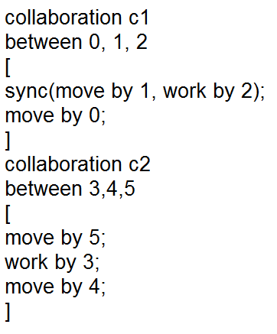
Figure 3.1 BoCoLa Eperiment 1 source code
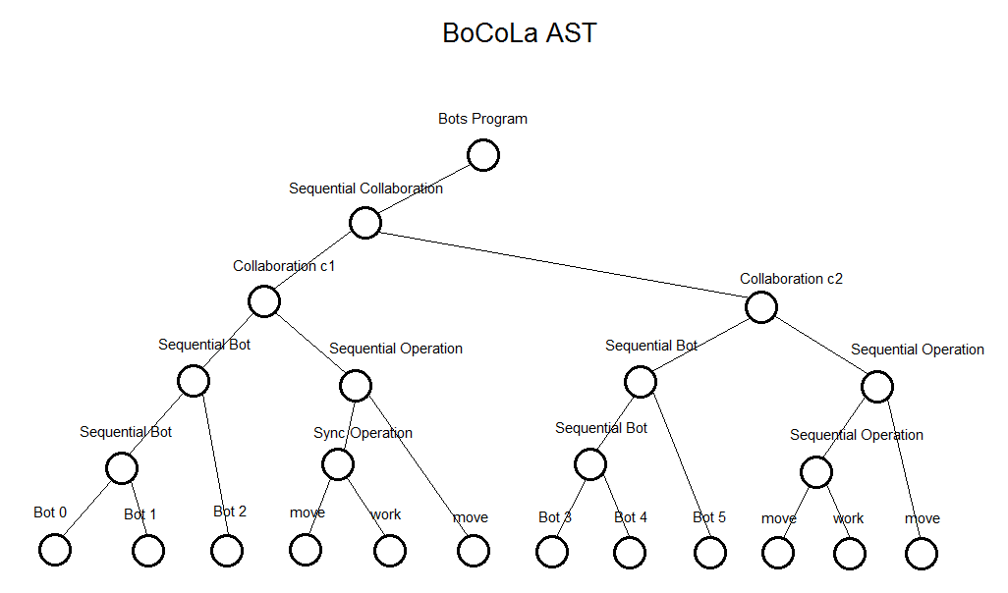
Figure 3.2 BoCoLa experiment 1 AST
The new Sync method that were added to the Parser class is shown in fig.3.3.
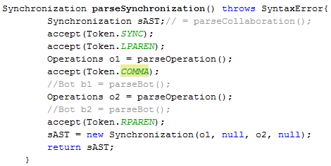
Figure 3.3 code snippet of the Synchronization method in the Parser class

4 – Runtime System Modification
In this section

Runtime system should be changed to get work of a new BoCoLa feature – synchronization. Then we execute our BotSystem program it includes bots into the lists. By default BotSystem has function include however if we want to include bots which have to be synchronized. That is why we created new function include which has twice more prams than default figure 4.1.
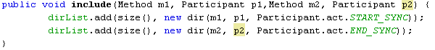

Figure 4.1: Synchronization between p1 and p2

Before we add to the dirList we mark participant that it is synchronized (START_SYNC, END_SYNC). Then runtime system executes it can easily check is it synchronized, and than locks other participants.
Modified BotsSystem shown in the figure 4.2.

l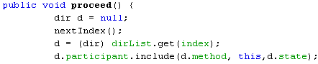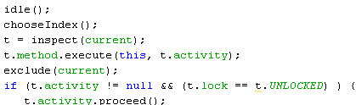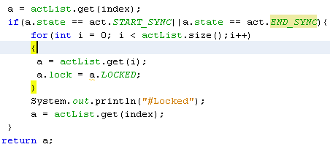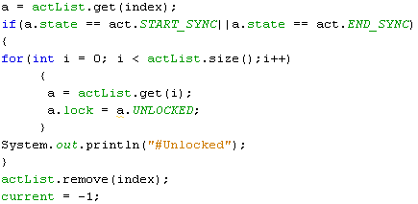
Activity
Participant
Lock

Locked
Unlocked
Figure 4.2: Run Time System (modified)

5 – Example Experimentation
In this section

6 – Conclusion

7 – Appendix

The source code is included in the zip file and on the CD.

